2.6: Lists Walkthrough

Within Python, we have a special type of variable which is able to hold multiple values. This is called a List (in other languages, a similar concept is arrays). These lists are able to store a collection of related data to be used. This allows you to operate either on the whole list, or individual elements. Each element can be referred to using its index. These indexes start at 0, so the element which is in the first position will be at index 0. When we create and use the lists, we use square brackets ([]).

We are going to create a list of names, which have the following items: alice, bob, charlie, and dave. The elements will be represented within the list as follows:

|  |  |  |  |  |
| --- | --- | --- | --- | --- |
| **Index** | 0 | 1 | 2 | 3 |
| **Content** | “alice” | “bob” | “charlie” | “dave” |

Enter the following code into your python file:

names = ["alice", "bob", "charlie", "dave"]

print(names)

print("Hello, World and "+names[0])

print("Hello, World and "+names[2])

Your Python file should now look like this:

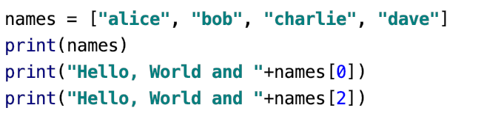

The first line of this code is used to define the names list and assign its contents. The final three lines are used to print either the full list, or individual elements.

When we run this program, you should get the following output:

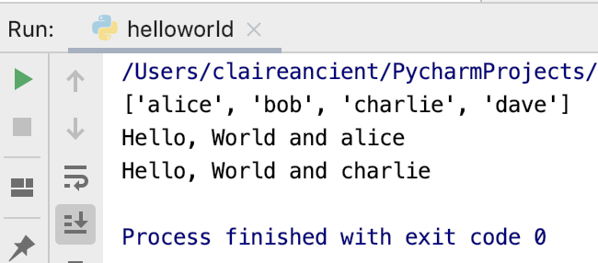

Now let’s try to make the code fail. Earlier, you saw that the maximum index was 3, so let’s try to access an element which is at a number higher than this:

print("Hello, World and "+names[5])

When you run the code, you should get the following output:

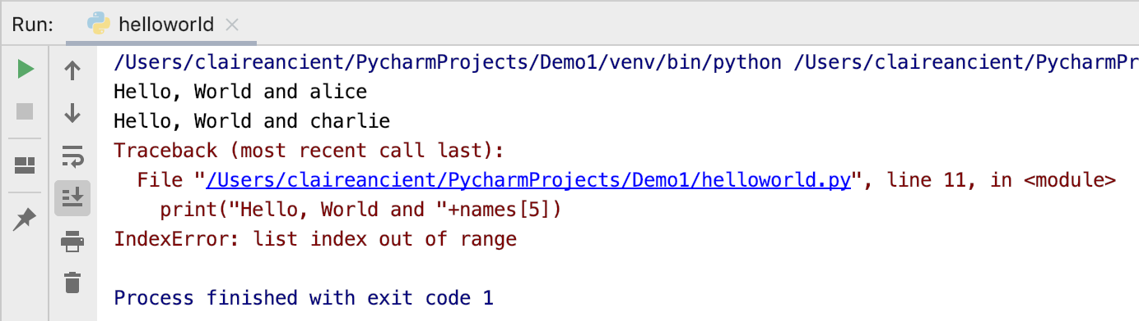

In Python, we get error messages which are relatively helpful (most of the time!). In this case, the Python interpreter has told us that we are trying to access an index which is out of range (i.e. we are trying to use an index which is higher than the maximum).